**527/2 AGRICULTURE**

**1(a) Put a spatulaful of A1 in a clean test tube, add distilled water leave it to settle for 30secs. Add 3 drops of universal indicator.**

(ii) A red colour was observed on mixing the universal indicator. 1mark

(iii) 1-3 1mark

(iv) A1 is acidic 1 mark

(v) Purple or dark blue colour was observed with universal indicator. 1 mark

(vi) 11-14 1 mark

(vii) A2 is acidic 1 mark

**(b) Causes (possible) one.**

**A1**

* Leaching of cations
* Volatilisation
* Use of organic fertilizers
* Use of acidic fertilizers
* Plant cation up take ( 1x1) marks
* Type of rock

**A2**

* Leaching
* Alkaline rocks
* Liming
* Plant up take of onions ( 1x1) marks

**(c) One possible control of A1 condition**

* Liming
* Use of Alkaline fertilizers (1x1) marks

**A2**

* Application of organic fertilizers
* Use of acidic fertilizers (1x1)marks

(1+1+1+1+1+1+1+1+1+1)= 10 marks

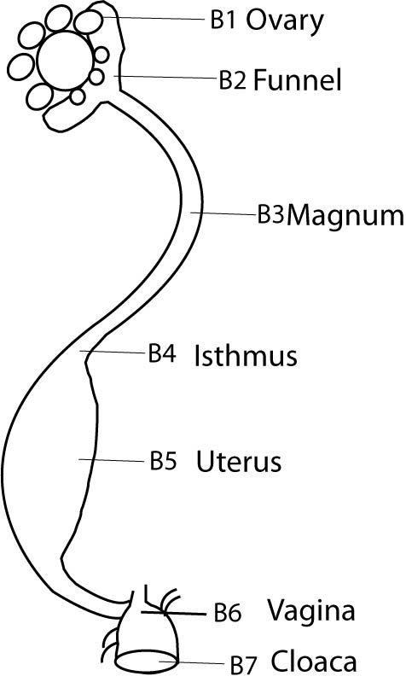**2. Draw and label the labeled parts B1, B2, B3, B4, B5, and B6**

Drawing-

Labelling- 3marks

**2. Give the functions of the parts labeled**

B2- challaza is added to the yolk.

B3 - Album is added to the cell

B4 – water is added to the cell

B5 – shell formation is conpled ($\frac{1}{2}$ x 4) 2 Marks

(b) How is part B6 adapted to its functions?

-Well lubricated - all the eggs to flow

-Large - can accommodate the egg

-It’s elastic - can accommodate all types of egg sizes.

(1x2) 2 Marks

**3 (a) Give the functions of each of the specimen and the system on which it belongs**

|  |  |  |
| --- | --- | --- |
| Specimen |  |  |
| H1 | Checks the level of oil in the pump | Lubrication system |
| H2 | Pumps water to the engine | Cooling system |
| H3 | Cools water before sending it to the engine | Cooling system |
| H4 | Transfers water to the engine from radiator | Cooling system |
| H5 | Blows air to cool water in the radiator | Cooling system |
| H6 | Filters oil | lubrication |
| H7 | Cleans air before sending it to carburator | Fuel system |

($\frac{1}{2}$ x14)=7 marks

**(b) How do H2 H3 H4 and H5 work collectively?**

Fan (H5) blows air and cool water in the radiator.

Radiator (H3) cools hot water from the engine.

Water pump (H2) pumps cool water to the engine form radiator

Hose pipe (H4) transfers cool water to the engine.

($\frac{1}{2}$ x4) =2 marks

**(c) Features which allow specimen H1 to perform it’s functions**

* It is calibrated to show oil quantity in the pump.
* Has a handle for handling.
* it is thin therefore , can pass through a narrow passage
* It is metallic therefore hard and can move without breaking. ($\frac{1}{2}$ x)

**4(a) Describe the appearance of K and L**

K-Sour milk 1mark

L-fresh milk contaminated with manure and fur 1mark

**(b)Nutrients provided by K and L**

1. Proteins
2. Minerals
3. Fats
4. Vitamins

($\frac{1}{2}$ x4) = 2 marks

(**c) Four ways in which conductors observed in K and L can be avoided**

* Cool milk after milking
* Boil milk after milking
* Use clean container
* Wash hands before milking
* Cover the milk after milking. ($\frac{1}{2}$ x4) = 2marks

**(d) 2ways in which the conditions observed in specimen L can be avoided.**

* Groom the animals
* Clean milking palour
* Wash hands

($\frac{1}{2}$ x2) = 2marks

**Four factors which affected the quality of K and L**

* Feed (nutrients)
* Cleaning milking containers
* Cool or boil the milk after milking
* Breed of the animal local breeds produced quality
* Season of the year dry season produce concentrated milk

($\frac{1}{2}$ x4) = 2marks

1+1+2+2+1+2= 9 Marks

**5(a) General term for specimens**

**Weeds** 1mark

**With the use of observation features/ reason state the life span**

|  |  |  |
| --- | --- | --- |
| Specimen | Life span | Observation feature/ reason |
| D | Annual | Has seeds, seed propagated |
| E | Perennial | Has pereneting ( underground struct |
| F | Annual | Has seeds, seed propagate |
| G | Perennial | Has an underground struct vegetatively propagated. |
| H | Annual | Seed propagated |

**(c) Economic importance of F and H**

They are poisonous weeds 1marks

(**d) How can E and G be effectively controlled**

* Chemicals appropriate /herbicides
* Dig out with a hoe

**End**